**AIRLINES TICKET RESERVATION SYSTEM**

**SIX WEEKS INDUSTRIAL TRANING PROJECT REPORT**

SUBMITTED FOR PARTIAL FULFILLMENTOF THE DEGREE

OF

**BACHELOR OF TECHNOLOGY**

(Computer Science & Engineering)



#### SUBMITTED BY: SUBMITTED TO:

Davinder Singh Prof. Sukhjit Singh Sehra

1507563

**Department of Computer Science and Engineering**

**Guru Nanak Dev Engineering College**

**LUDHIANA, 141006**

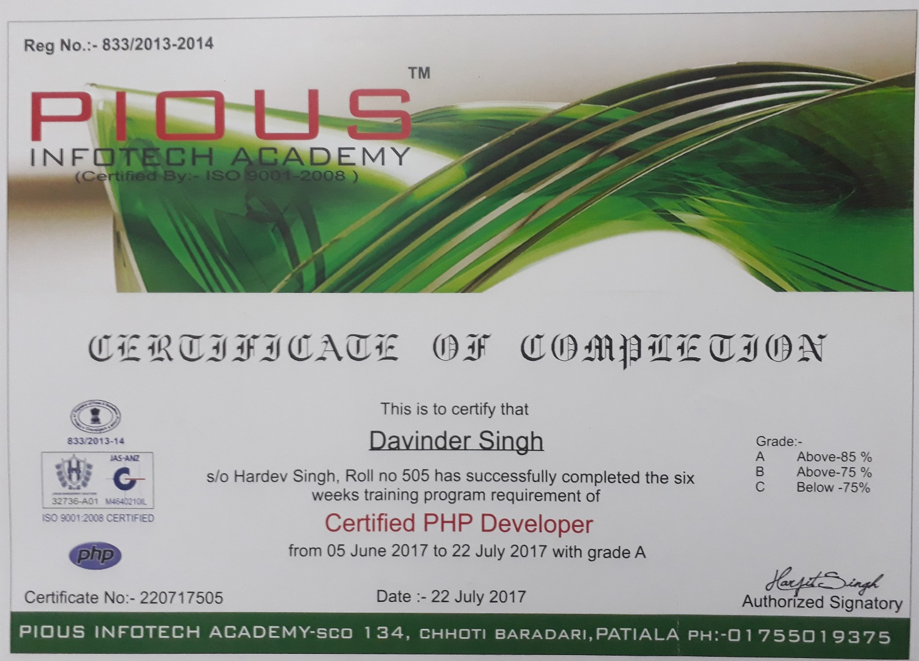

**ABSTRACT**

The design of such a project is made in html 5 and php. The purpose of the final Web site is

to help students to communicate with faculty members and publically aware about the activities done in the university. It is a system of databases that allows Student and their documents shared by faculty member. Also used knowledge of php and html5 language during project. This project is an online site between students and faculty. This innovative system allows college faculty to share important data as well as notifications with engineering students. It consists of a faculty login along with student login. Faculty may upload documents of subject syllabus, attendance, notifications, notices, assignments etc through their provided login. The documents are uploaded by faculty to different corresponding departments. We propose to build this system on an online server that allows faculty to upload data and students may view search and download required documents through their device. Here students only see and download data of their particular year. Here students only see and download data of their particular batch and class. Rest data is hidden. Faculty may access and upload/edit documents to any semester or add any notice as desired.

**ACKNOWLEDGEMENT**

I am highly grateful to the Dr. M.S. Saini, Director, Guru Nanak Dev Engineering College (GNDEC), Ludhiana, for providing this opportunity to carry out the six week industrial training project work. The constant guidance and encouragement received from Er.Parampreet Singh, founder of Pious Institute Patiala has been of great help in carrying out the project work and is acknowledged with reverential thanks.

**Davinder Singh**

**TABLE OF CONTENTS**

1. **Introduction To Project 6-8**

1.1 Overview of Project

1.2 Project Category

1.3 Objective

1.4 Existing System

1.5 Proposed system

2. **Requirements Analysis and System Specification 9-12**

2.1 Feasibility Study

2.2 Software Requirements Specification

2.3 SDLC model

**3. System Design 13-19**

3.1 Html 5 and PHP

3.2 Flowcharts and DFDs

3.3 Database Design

3.4 ER Diagram

3.5 Methodology

**4**.  **Implementation, Testing and Maintanance 20-27**

4.1 Introduction to Languages

4.2 Testing

**5. Result and Discussions 28-31**

4.1 Table Structure

4.2 Snapshots

**6. Conclusion and Future Scope 32**

**7. References 33**

**Chapter 1**

**Introduction to Project**

* 1. **Overview**

The main purpose of this software is to reduce the manual errors involved in the airline reservation process and make it convenient for the customers to book the flights as when they require such that they can utilize this software to make reservation, modify reservations or cancel a particular reservation. The name of the software is “AIRLINE RESERVATION SYSTEM”. This software provides options for viewing different flights available with different timings for a particular date and provides customers with the facility to book a ticket, modify or cancel a particular reservation but it does not provide the customers with details of cost of the ticket and it does not allow the customer to modify a particular part of his reservation and he/she can modify all details.

* 1. **Project Category**

This Project is an internet based application which can be used by any user for online ticket reservation for airlines, which decreases paper work. This Project also helps in System Administration.

1.3 Objectives of Project

The main objective of this project is to develop an Web site that allows user to book airline tickets online. The project has the following objectives:

* Attractive and Easy to Use: This means customization and adaptation capabilities according to each users experience, habits and personal preferences.
* Extensible: Through the use of proper design decisions and used technologies.
* Efficiency: In terms of the quality of search result, response time, navigation performance.
* Flexibility: The system should be modifiable depending on the changing needs. It Provide a proper interface to manage all the items information. It should also be open on any web browsers to different computer systems.
* User -Friendly: Easy to use with attractive user interface.

**1.4 Existing System**

The effectiveness of the system depends on the way in which the data is organized .In the existing system, much of the data is entered manually and it can be very time consuming. When records are accessed frequently, managing such records becomes difficult. Therefore organizing data becomes difficult. The major limitations are:

• Modifications are complicated

• Much time consuming

• Error prone

• Unauthorized access of data

* + 1. **Identification/Recognition of Need**

**1. Save money on papers:** it could save our expenses of paper and other file and hard copies.

**2. Helpful for the organization:** Web site will helps the student and organization both to manage the work.

**1.5 PROPOSED SYSTEM:**

The proposed system is better and more efficient than existing System by keeping in mind all the drawbacks of the present system to provide a permanent to them.

The primary aim of the new system is to speed up the transactions. User friendliness is another peculiarity of the proposed system. Messages are displayed in message boxes to make the system user friendly. The main Advantage of the proposed system is the reduction in labor as it will be possible so search the details of various 10 places. Every record is checked for completeness and accuracy and then it is entered into the database. The comments and valid messages are provided to get away redundant data. Another important feature of the proposed system is the data security provided by the system. The main objectives of the proposed system are:

• Complex functions are done automatically

• Processing time can be minimized

• Simple and easy to manage

• Chances of errors reduced

• Faster and more accurate than the existing system

• Easy for handling reports

The proposed system is complete software for Airline Reservation System, Which is more efficient, reliable, faster and accurate for processing.

**Chapter-2**

**Requirements analysis and system specification.**

**2.1 Feasibility Study**

The study of the project provide the information about the work done in creating the site and the other information about the techniques and the different features are required to create a website .In this study we get to know about the possible outcomes of the project and the proper working of the project.

**2.1.1 Economical Feasibility**

In making recommendations a study of the economics of the proposed system should be made. Even though finding out the costs of the proposed project is difficult we assume and estimate the costs and benefits as follows. According to the computerized system we propose, the costs can be broken down in two categories.

1 Costs associated with the development of the system.

2 Costs associated with operating the system.

**2.2 Software requirements and specifications**

1. **Software required.**

* **Dreamweaver** :- Dreamweaver is an application used by web designers and developers to create websites and applications for use across multiple targets including browser s , devices and tablets.

Web designers use DREAMWEAVER foe creating website prototype using web- friendly artwork.

Dreamweaver is a proprietary web development tool developed by Adobe Systems.

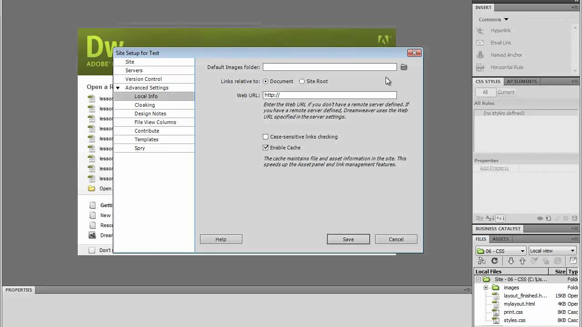

* **Xampp**:- **WAMP** stands for windows, apache, mysql, php. • **XAMPP** stands for x- os, apache, mysql, php , perl. (x-os means it can be used for any operating system.)

so you not **need** to install mysql database server separately. for php website **xampp**is compulsory , but fore java you not **need** a **xampp** for mysql dabase compulsory . you can download mysql from his official website and used it for your java application . **xampp** is not needed for java application .

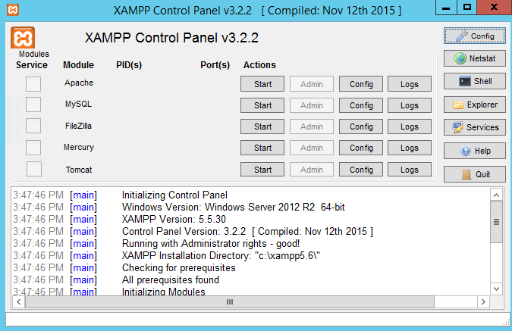

2. **Hardware requirement**

|  |  |
| --- | --- |
| Physical memory (RAM) | 512 MB recommended |
| Virtual memory | Double the amount of RAM |
| Temp disk space | Hard disk space 40 GB |
| Video adapter | 256 colors |
| CPU Processor | 2.00 GHz minimum |
| Net Connectivity | Network adapter required |

**2.3 SDLC model**

SDLC or Software Development Life Cycle deals with online programs or computer software. Different types of designs were created to cater to the need of individual programmers with different set of skills, demands or business environment. As the name suggests, it is only limited to creating software.

However, our world is not all about software. Everyday, we use the internet and visit different websites to learn, to shop, to do business or even have fun. And the development of a specific website is not just writing anything in HTML with the hope that someone will visit and in your end you will eventually through advertising sales or anything.

Website creation also takes planning and the good news is that SDLC could also be applied to Web Development. Since there are so many websites out there that also works as tools becoming online software, it is no wonder why SDLC is also applicable in Web Development.

In this chapter we take a look at different factors and steps in applying SDLC in Web Development. You will be able see how relevant a website could be in developing software. Although they serve different purpose, it is almost the same from the early stages. The only differences are the actual application which we will look at them one by one.

Factors in SDLC for Web Development will also be discussed in this chapter. It should happen in an entirely different environment and there are different players now that instead of creating software, it is now focused on the creation of a fully functional website that has the ability to earn, and inform it is intended audience.

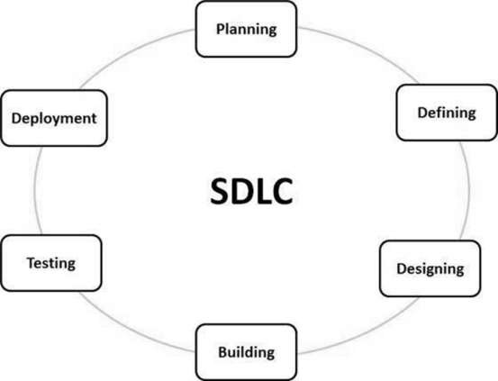

**Chapter – 3**

**System Design**

**3.1 HTML 5 and PHP**

* **Html 5**

HTML5 includes detailed processing models to encourage more interoperable implementations; it extends, improves and rationalizes the markup available for documents, and introduces markup and [application programming interfaces](https://en.wikipedia.org/wiki/Application_programming_interface) (APIs) for complex [web applications](https://en.wikipedia.org/wiki/Web_application).[[6]](https://en.wikipedia.org/wiki/HTML5#cite_note-HTML5diffHTML4-7) For the same reasons, HTML5 is also [a candidate for cross-platform mobile applications](https://en.wikipedia.org/wiki/HTML5_in_mobile_devices), because it includes features designed with low-powered devices in mind.

Many new [syntactic](https://en.wikipedia.org/wiki/Syntax_(programming_languages)) features are included. To natively include and handle [multimedia](https://en.wikipedia.org/wiki/Multimedia) and [graphical](https://en.wikipedia.org/wiki/2D_computer_graphics) content, the new [<video>](https://en.wikipedia.org/wiki/HTML5_video), [<audio>](https://en.wikipedia.org/wiki/HTML5_Audio) and [<canvas>](https://en.wikipedia.org/wiki/Canvas_element)[elements](https://en.wikipedia.org/wiki/HTML_element) were added, and support for scalable vector graphics ([SVG](https://en.wikipedia.org/wiki/Scalable_Vector_Graphics)) content and [MathML](https://en.wikipedia.org/wiki/MathML) for mathematical formulas. To enrich the [semantic](https://en.wikipedia.org/wiki/Semantic_Web) content of documents, new page structure elements such as <main>, <section>, [<article>](https://en.wikipedia.org/wiki/Article_element_(HTML5)), <header>, <footer>, <aside>, <nav> and <figure>, are added. New [attributes](https://en.wikipedia.org/wiki/HTML_attribute) are introduced, some elements and attributes have been removed, and others such as <a>, <cite> and <menu> have been changed, redefined or standardized.

* **PHP**

PHP stands for **P**HP: **H**ypertext **P**reprocessor, PHP is a server-side scripting language,**PHP** is a widely used, general-purpose scripting language that was originally designed for web develoment, to producedynamic web pages. It can be embedded into HTML and generally runs on a web server, which needs to be configured to process PHP code and create web page content from it. It can be deployed on most web servers and on almost every operating system and platform free of charge. PHP is installed on over 20 million websites and 1 million web server

The main implementation of PHP is now produced by **The PHP Group** and serves as the for PHP as there is no formal specification. PHP is free software released under the PHP license, That's a mouthful, but if we break the definition down into smaller pieces, it is easier to understand.

* **Server-Side**: This means that PHP scripts execute on the Web server, not within the browser on your local machine.
* **Cross-Platform**: Cross-platform means that PHP scripts can run on many different operating systems and Web servers. PHP is available for the two most popular Web server configurations (IIS running on Windows NT and Apache running on UNIX).
* **HTML embedded scripting language**: This means that PHP statements and commands are actually embedded in your HTML documents. When the Web server sees the PHP statements in the Web page, the server executes the statements and sends the resulting output along with the rest of the HTML. PHP commands are parsed by the server much like Active Server Pages or Cold Fusion tags

**3.2.** **Flowcharts and DFDs**

Data flow diagrams are useful throughout the analysis and design process. Use original, unexploded data flow diagrams early when ascertaining information requirements. At this stage they can help provide an overview of data movement through the system, lending a visual perspective unavailable in narrative data.

A systems analyst might be quite competent at sketching through the logic of the data stream for data flow diagrams, but to make the diagrams truly communicative to users and other members of the project team, meaningful labels for all data components are also required. Labels should not be generic, because then they do not tell enough about the situation at hand. All general systems models bear the configuration of input, process, and output, so labels for a data flow diagram need to be more specific.

**DFD Symbols**

In the DFD, there are four symbols,

1. **A Square** defines a source (originator) or destination of system data.
2. **An Arrow** identifies data flow- data in motion .It is pipeline through which information flows.
3. **A circle** or a **bubble** (or a oval bubble) represents a process that transforms incoming data flow(s) into outgoing data flow(s)
4. **An Open rectangle** is a data store-data at rest, or temporary repository of data.

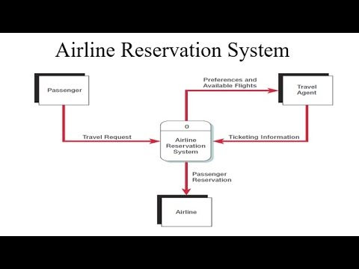

**3.3 Database Design**

* **What is database?**

**Database design** is the process of producing a detailed [data model](https://en.wikipedia.org/wiki/Data_model) of a [database](https://en.wikipedia.org/wiki/Database). This data model contains all the needed logical and physical design choices and physical storage parameters needed to generate a design in a [data definition language](https://en.wikipedia.org/wiki/Data_definition_language), which can then be used to create a database. A fully attributed data model contains detailed attributes for each entity.

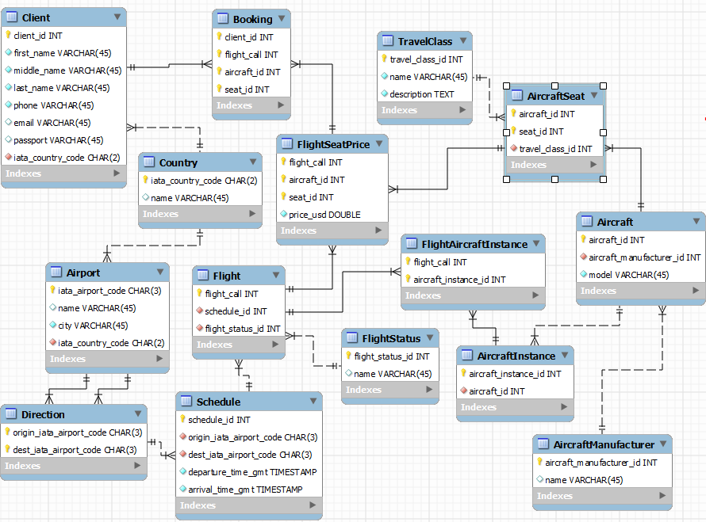

**3.4 ER Diagram**

An entity relationship model, also called an entity-relationship (ER) diagram, is a graphical representation of entities and their relationships to each other, typically used in computing in regard to the organization of [data](http://www.webopedia.com/TERM/D/data.html) within [databases](http://www.webopedia.com/TERM/D/database.html) or information systems. An entity is a piece of data-an [object](http://www.webopedia.com/TERM/O/object.html)or concept about which data is stored.

In an ER diagram, symbols are commonly used to to represent the types of information. Most diagrams will use the following:

* Boxes represent entities.
* Diamonds represent relationships
* Circles (ovals) represent attributes.

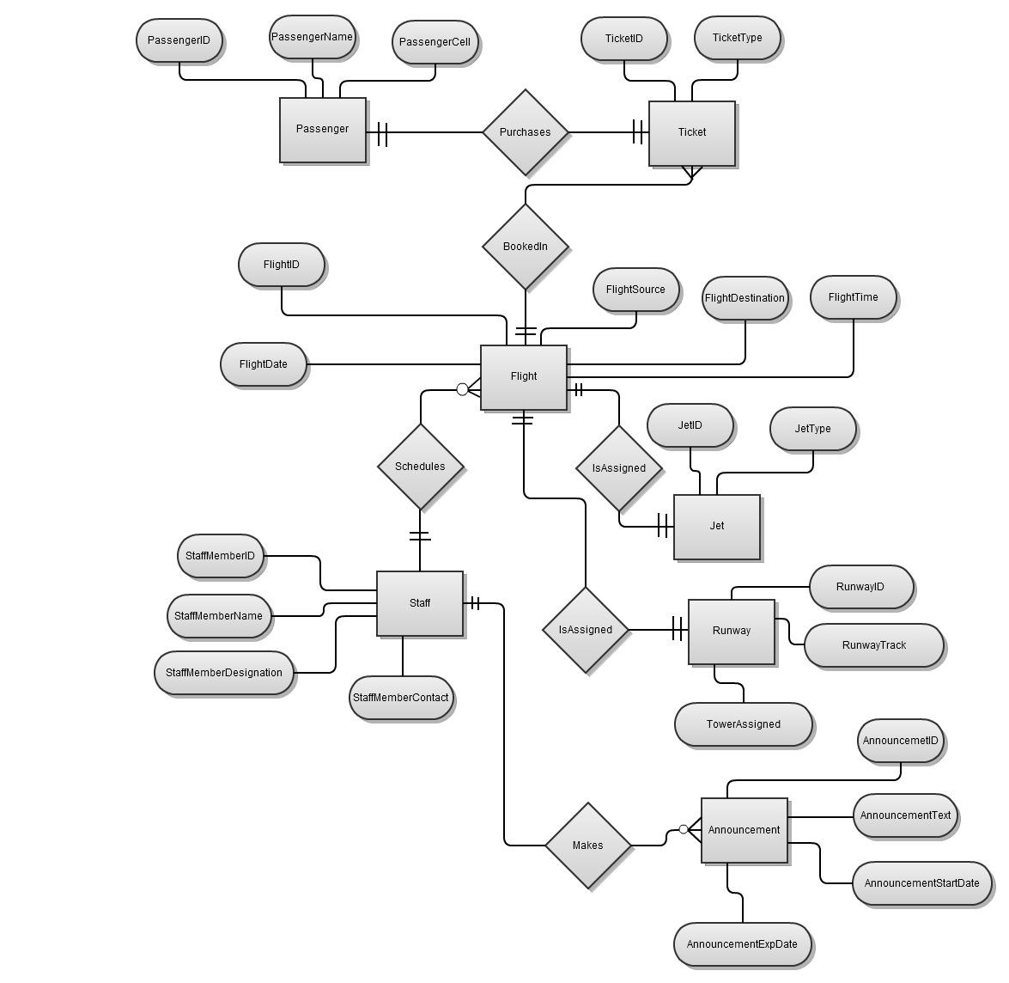

**3.5 Methodology**

Our methodology is designed to help you take maximum advantage of the internet technologies. It incorporate all aspects related to your website and allows us to ensure that the final product is of the highest standards. Below are the steps we will take to ensure that all your deliverables are completed in time and within budget.

## 1. Requirements analysis

The first step for us is to analyse your and your target market’s requirements. Who will be visiting your website, what will be the purpose of their visit, what is the primary goal of your website, how can your organisation best cater to their needs etc. Many such questions are analysed for the Needs Analysis stage.

If we are given access to the current website statistics, we would also like to analyse your current page views, average user time spent on the site, top landing pages, existing search engine rankings, existing bounce rates and many such factors. We analyse your online target audience and assess your differentiation strategy to best attract and retain your online visitors.

Your website will also undergo comprehensive search engine analysis twice during the course of the project; once during this stage and once again after the deployment (Go Live phase) of your website.

## 2. Formulate digital strategy

Based on the needs analysis, we determine the factors that will best serve your website. We look at the trends in the market to ensure that you have the latest technology, components and elements. We take time to think outside the box and give consideration to more than your present day business needs so that your website can sustain any upcoming future needs.

As a part of this phase, we also finalise the primary and secondary keywords or key-phrases for your website. These primary and secondary keywords or key-phrases are then used throughout the website development phases.

## 3. Web-page conceptualisation

We consider this stage to be one of the most crucial factors in any project. We justify every single aspect of the design to ensure that each element is serving a specific need and the website is truly designed to attract, retain and enhance the end user-experience.

We will be to develop three custom built, high-end website design templates or concepts, incorporating your marketing and communication strategy. Many thought processes and brainstorming will go into this process to create a design that is serving your existing needs as well as is sustainable with the future growth. Together with your input, we’ll come up with the designs that will effectively communicate your brand and online identity to your stake holders.

The finalised concepts or templates will then be used for two other internal pages to give you an understanding of how internal content intensive pages will look.

At this stage, we will submit designs and concepts for your review and feedback.

## 4. Web Development

Once we have received your acceptance of the detailed design, we proceed to the HTML development and CMS configuration phase. Primary and Secondary keywords or key-phrases are used throughout the development.

The HTMLs are prepared in accordance with the W3C standards. Our well experienced team has in-depth understanding of the W3C standards such as CSS, XHTML etc. Your websites will be built using these proven standards.

Once all developments are done, we proceed to the Testing phase, where features of your website and the Content Management System is tested rigorously.

Once the preliminary testing is done, we then proceed to the multi-browser test, where your website is tested over major browsers such as IE, Firefox & Safari as a standard practice. If you require yoru website to be tested on more browser, simply ask us to have them included in the testing phase for your project.

For your information, the latest worldwide browser statistics are as follows.

As discussed previously, we would also like to analyse browser and platform statistics of your website at the planning phase to ensure that your new website is built accordingly.

**Chapter – 4**

**Implementation and Testing**

**4.1 Introduction to languages**

**4.1.1 MYSQL ( Structue Query Language)**

SQL is a standard computer language for accessing and manipulating databases.

**What is SQL?**

* SQL stands for Structured Query Language
* SQL allows you to access a database
* SQL is an ANSI standard computer language
* SQL can execute queries against a database
* SQL can retrieve data from a database
* SQL can insert new records in a database
* SQL can delete records from a database
* SQL can update records in a database
* SQL is easy to learn

**MySQL** is a (RDBMS) which has more than 6 million installations. MySQL stands for "My Structured Query Language". The program runs as a server providing multi-user access to a number of databases.

The project's source code is available under terms of the GNU , as well as under a variety agreement properitys. MySQL is owned and sponsored by a single for profit firm, the company, now a of which holds the copyright to most of the codebase.

**Uses of MYSQL**

MySQL is used in web application and acts as the database component of the LAMP software stack. Its popularity for use with web applications is closely tied to the popularity of PHP , which is often combined with MySQL.

**Platforms and Interfaces**

The MySQL Administrator in Linux

MySQL is written in C and C++. The SQL parser uses and a home-brewed, sql_lex.cc.

MySQL works on many different system platform including

Libraries for accessing MySQL databases are available in all major programming languages with language-specific APIs . In addition, an ODBC interface called MyODBC allows additional programming languages that support the ODBC interface to communicate with a MySQL database, such as ASP or ColdFusion. The MySQL server and official libraries are mostly implemented in ANSI C/ANSI C++.

To administer MySQL databases one can use the included command-line tool (commands: mysql and mysqladmin). Also downloadable from the MySQL site are GUI administration tools: MySQl Administrator MySQL Migration Toolkit and MySQL Query Browser. The GUI tools are now included in one package called MySQL GUI Tools.

In addition to the above-mentioned tools developed by MySQL AB, there are several other commercial and non-commercial tools available. Examples include Navicat Free Lite Edition or SQLyog Community Edition, they are free desktop based GUI tools, and phpMyAdmin, a free Web-based administration interface implemented in PHP.

**Features of MYSQL**

As of April 2009[[update]](http://en.wikipedia.org/w/index.php?title=MySQL&action=edit), MySQL offers MySQL 5.1 in two different variants: the MySQL Community Server and Enterprise Server. They have a common code base and include the following features:

* A broad subset of ANSI SQL 99, as well as extensions
* Cross-platform support
* Stored procedures
* Triggers
* Cursors
* Updatable Views
* True Varchar support
* INFORMATION_SCHEMA
* Strict mode
* Query caching
* Sub-SELECTs (i.e. nested SELECTs)
* Replication with one master per slave, many slaves per master, no automatic support for multiple masters per slave.
* Full-text indexing and searching using MyISAM engine
* Embedded database library
* Partial Unicode support (UTF-8 sequences longer than 3 bytes are not supported; UCS-2 encoded strings are also limited to the BMP)

The MySQL Enterprise Server is released once per month and the sources can be obtained either from MySQL's customer-only Enterprise site or from MySQL's Bazaar repository, both under the GPL license. The MySQL Community Server is published on an unspecified schedule under the GPL and contains all bug fixes that were shipped with the last MySQL Enterprise Server release. Binaries are no longer provided by MySQL for every release of the Community Server.

**SQL is a Standard - BUT....**

SQL is an ANSI (American National Standards Institute) standard computer language for accessing and manipulating database systems. SQL statements are used to retrieve and update data in a database. SQL works with database programs like MS Access, DB2, Informix, MS SQL Server, Oracle, Sybase, etc.

Unfortunately, there are many different versions of the SQL language, but to be in compliance with the ANSI standard, they must support the same major keywords in a similar manner (such as SELECT, UPDATE, DELETE, INSERT, WHERE, and others).

**SQL Database Tables**

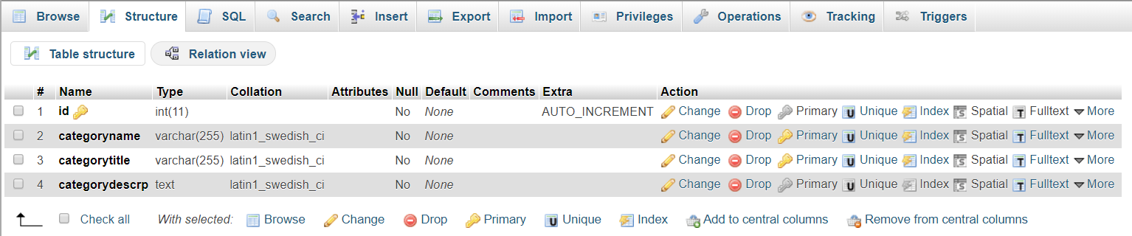

**4.1.2 Cascading Style Sheet**

**Cascading Style Sheets** (**CSS**)A CSS (cascading style sheet) file allows you to separate your web sites (X) HTML content from it’s style. As always you use your (X)HTML file to arrange the content, but all of the presentation (fonts, colors, background, borders, text formatting, link effects & so on…) are accomplished within a CSS.

At this point you have some choices of how to use the CSS, either internally or externally.

### Sources

* **Internal Style sheet**

First we will explore the internal method. This way you are simply placing the CSS code within the <head></head> tags of each (X)HTML file you want to style with the CSS. The format for this is shown in the example below.

<head>  
<title><title>  
<styletype=”text/css”>  
CSS Content Goes Here  
</style>  
</head>  
<body>

With this method each (X)HTML file contains the CSS code needed to style the page. Meaning that any changes you want to make to one page, will have to be made to all. This method can be good if you need to style only one page, or if you want different pages to have varying styles.

* **External Style sheet**

Next we will explore the external method. An external CSS file can be created with any text or HTML editor such as “Notepad” or “Dreamweaver”. A CSS file contains no (X)HTML, only CSS. You simply save it with the .css file extension. You can link to the file externally by placing one of the following links in the head section of every (X)HTML file you want to style with the CSS file.

<link rel=”stylesheet” type=”text/css” href=“Path To stylesheet.css” />

Or you can also use the @import method as shown below

<style type=”text/css”>@import url(Path To stylesheet.css)</style>

## Benefits OF CSS

CSS was a revolution in the world of web design. The concrete benefits of CSS include:

* control layout of many documents from one single style sheet;
* more precise control of layout;
* apply different layout to different media-types (screen, print, etc.);
* numerous advanced and sophisticated techniques.

**Advantages of CSS**

**Separation of content from presentation**

CSS facilitates publication of content in multiple presentation formats based on nominal parameters. Nominal parameters include explicit user preferences, different web browsers, the type of device being used to view the content (a desktop computer or mobile Internet device), the geographic location of the user and many other variables.

**Site-wide consistency**

When CSS is used effectively, in terms of inheritance and "cascading," a global style sheet can be used to affect and style elements site-wide. If the situation arises that the styling of the elements should need to be changed or adjusted, these changes can be made by editing rules in the global style sheet. Before CSS, this sort of maintenance was more difficult, expensive and time-consuming.

**Bandwidth**

A style sheet, internal or external, will specify the style once for a range of HTML elements selected by class, type or relationship to others. This is much more efficient than repeating style information inline for each occurrence of the element. An external stylesheet is usually stored in the [browser cache](http://en.wikipedia.org/wiki/Browser_cache), and can therefore be used on multiple pages without being reloaded, further reducing data transfer over a network.

**4.2 Testing**

**TEST PLAN**

Once the code has been written, program testing begins. The testing process focuses on the logical internals of the software, ensuring that all statements have been tested, and on the functional externals; that is, conducting tests to uncover errors end to ensure that the defined input will produce the desired output. The project has been tested on dummy as well as live data.

Following steps were carried out during testing:

**1. ONLINE RESPONSE**

Our project is such that it requires optimum response time and it does not cause any hardship to the user. We have tested it in the peak hours and time to establish a true performance level.

**2. VOLUME**

We created as many records as are normally produced to verify that the hardware and software function correctly. The users were asked to provide test data for the test.

**3. STRESS TESTING**

In this test, the system was subjected to high volume of data over a short time period.

**4. RECOVERY AND SECURITY**

A forced system failure was induced to test a backup recovery produce for file integrity. Inaccurate data were entered to see how the system responds in terms of error detection and protection. The Administrator, Key users and End users are recognized by their User IDs and Passwords in order to prevent any unauthorized access to the system

**5. USABILITY DOCUMENTATION AND PROCEDURE**

This test was carried out to verify the user-friendly nature of the system. This included normal operating and error handling procedures.

Testing is a critical element of quality assurance and representations the ultimate review of specification, design and code generation. This stage is the validation of the program. It ensures that the program performs correctly the required tasks. Once code has been generated, project must be tested to uncover as many errors as possible before delivery to the customer. The testing process focuses on the logical internals of the software, ensuring that all statements have been tested, and on the functional externals; that is conducting test to uncover errors and ensures that defined input will produce actual results that agree with required results.

**TESTING OBJECTIVES**

a) Testing is a process of executing a program with the intent of finding an error.

b) A good test is one that has a high probability of finding an as-yet-undiscovered error.

c) A successful test is one that uncovers an as-yet-undiscovered error.

If testing is conducted successfully, it will uncover errors in the software or in your project.

As a secondary benefit, testing demonstrates that software functions appear to be working according to specification, that behavioral and performs requirements appear to have been met. But testing can’t show the absence of errors and defects, it can show only that software errors and defects are present.

**Chapter – 5**

**Result and Discussion**

**5.1 Snapshots**

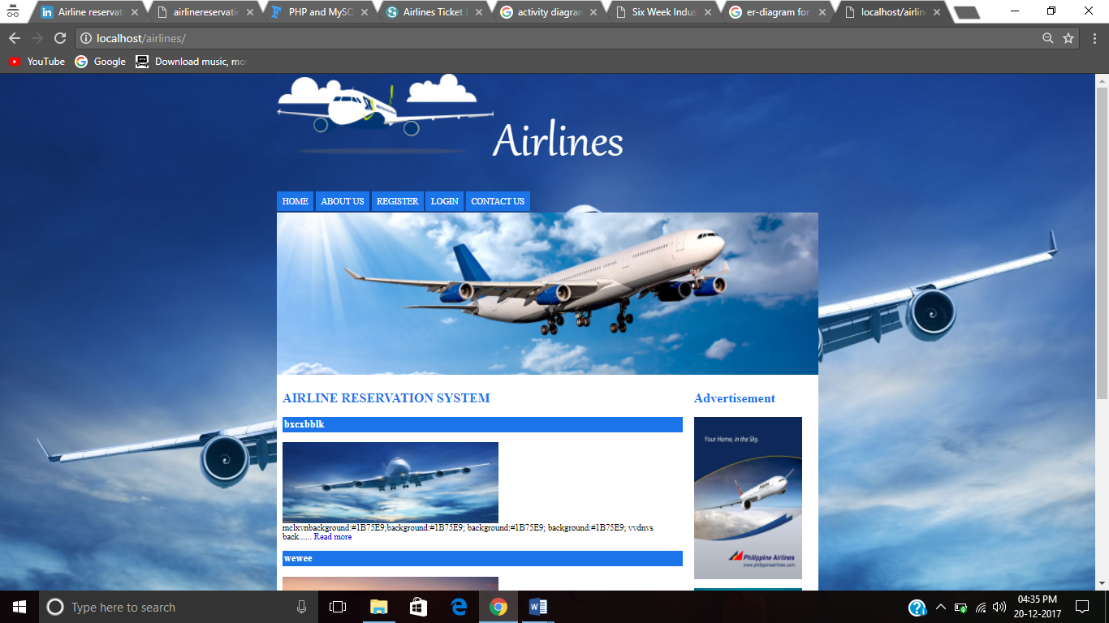

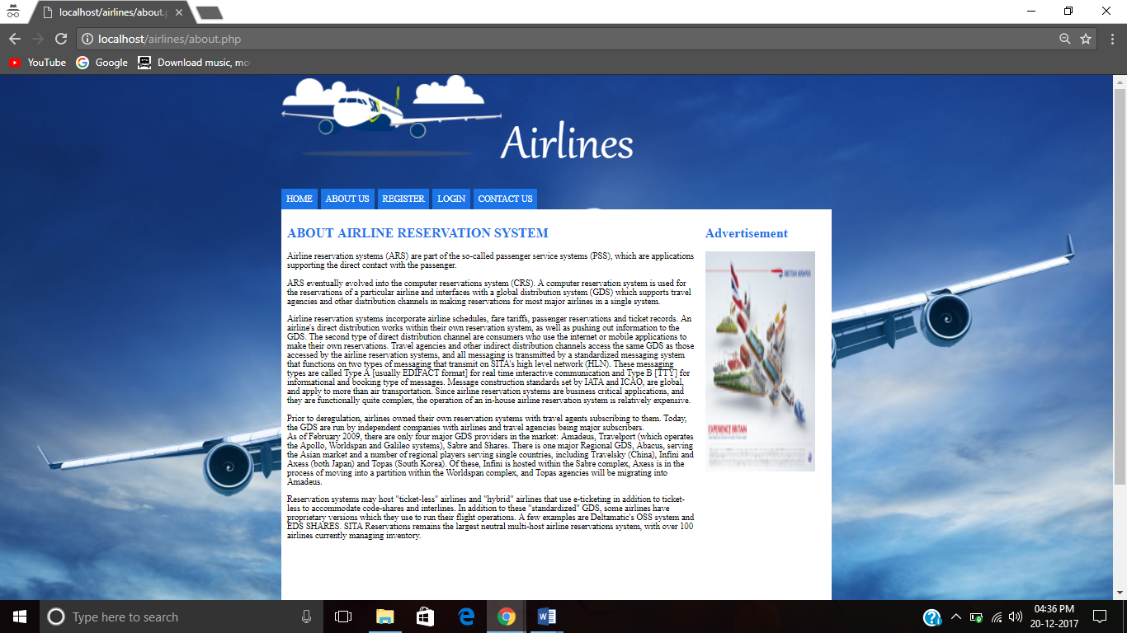

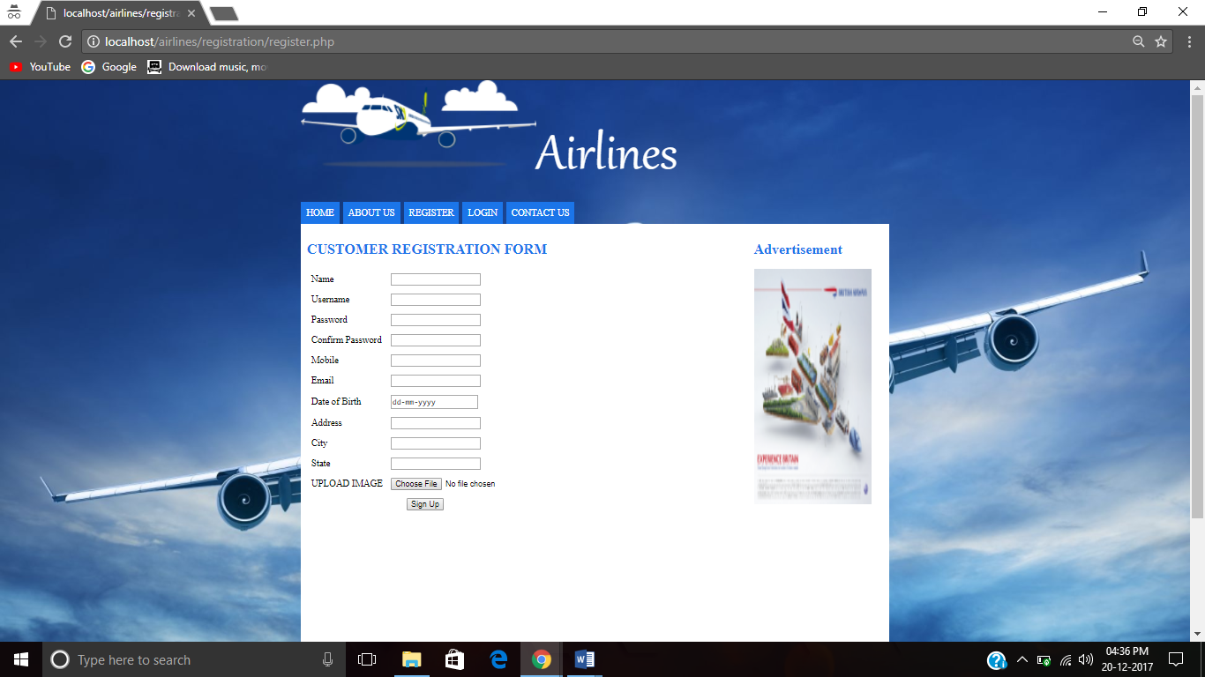

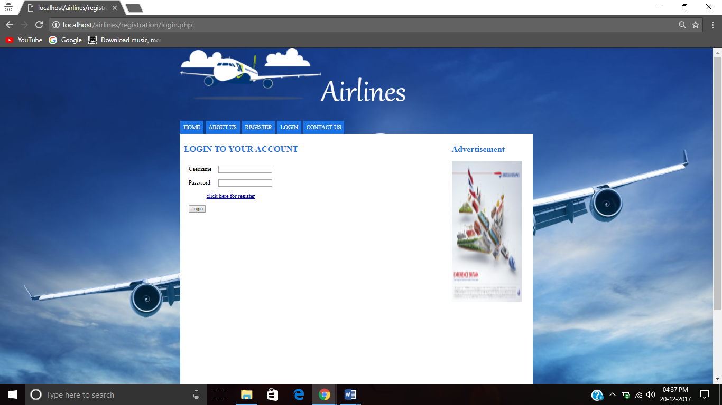

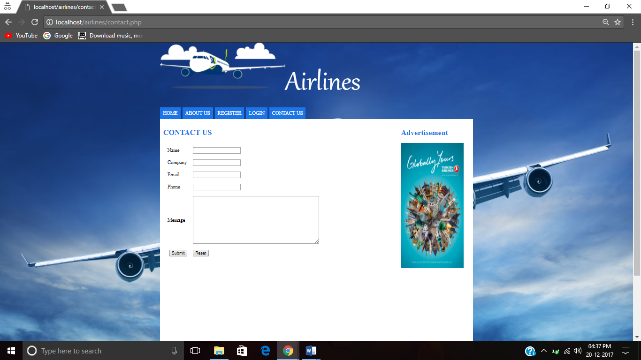

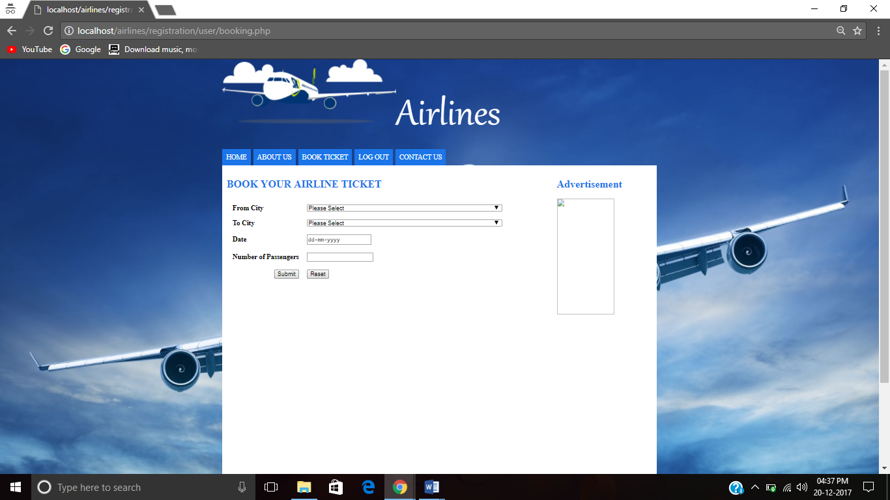

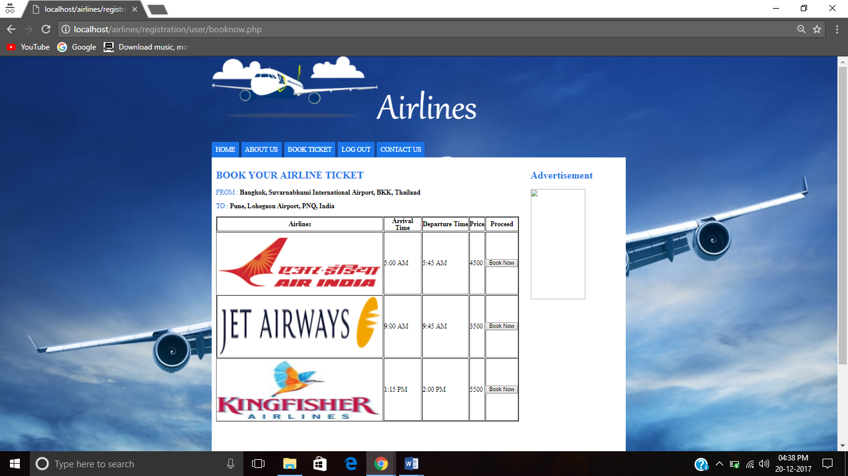

**Chapter – 6**

**Conclusion and Future Scope**

**Conclusion**

Our project is only a humble venture to satisfy the needs to manage their project work. Several user friendly coding have also adopted. This package shall prove to be a powerful package in satisfying all the requirements of the school. The objective of software planning is to provide a frame work that enables the manger to make reasonable estimates made within a limited time frame at the beginning of the software project and should be uploaded regularly as the project progresses.

**At the end it is concluded that we have made efforts on following points..**

* + A description of the background and context of the project and its relation to work already done in the area.
  + Made statement of the aims and objectives of the project.
  + The description of purpose, scope, and applicability.
  + We define the problem on which we are working in the project.
  + We describe the requirements specifications of the system and the actions that can be done on these things.
  + We understand the problem domain and produce a model of the system, which describes operations that can be performed on the system.
  + We include the features and operations in detail, including screen layouts.
  + We designed user interface and security issues related to system.
  + Finally the system is implemented and tested according to test cases.

**Future scope**

Airline Reservation System is one the modifications that were carried out in the Passenger Service System so that the working and availability of Service area can be broadened.   
  
This is basically an interface of Global distribution System to carry out reservations on the desired airline from any place. Airline Reservation System make the life of passengers very easy as they don’t need to stand in queues for getting their seats reserved and they can easily make reservations on any airline just from a single system. On the other hand, it also removed an extra burden from the Airline Department as most of the passengers and travel agencies use this service instead of making reservations from the counters

**Chapter-7**

**References**

* “Learning PHP and MySQL”, Michele E. Davis & Jon A.Phillips.
* “Build Your Own Data Driven Website Using PHP & MySQL”, Kevin Yank.
* http://www.php.net
* <http://www.wikipedia.org>
* www. W3schools.com